**Ideation Phase**

**Define the Problem Statements**

|  |  |
| --- | --- |
| Date | 22 October 2022 |
| Team ID | PNT2022TMID17729 |
| Project Name | Project - Project – PERSONAL ASSISTANCE FOR SENIORS WHO ARE SELF-RELIANT |
| Maximum Marks | 2 Marks |

**Customer Problem Statement Template:**

Some people find it difficult to learn new apps in this ever-expanding digital environment, and people nowadays tend to forget things more easily, such as taking their prescriptions. People need a way to remember to take their prescriptions without having to learn how to use sophisticated programs.

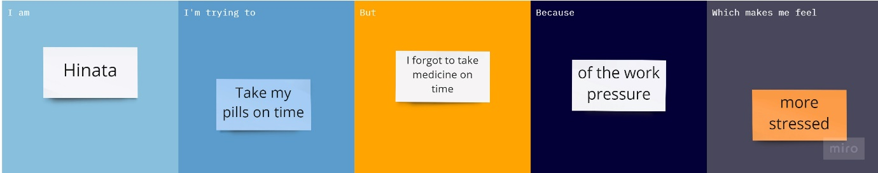

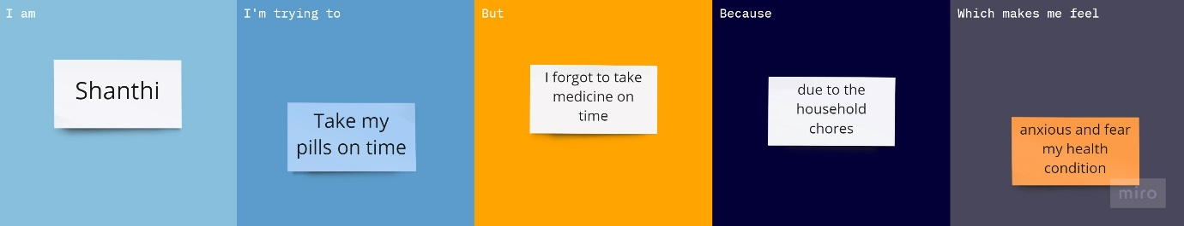

|  |  |  |  |  |  |
| --- | --- | --- | --- | --- | --- |
| **Problem Statement (PS)** | **I am (Customer)** | **I’m trying to** | **But** | **Because** | **Which makes me feel** |
| PS-1 | Hinata | Take my pills on time | I forgot to take my medicine on time | Of the work pressure | More stressed |
| PS-2 | Shanthi | Take my pills on time | I forgot to take my medicine on time | Due to the household chores | Anxious and fear about my health condition |